Figure 1 presents the detailed procedures for handling both RREQ and RREP messages. Every node in multi-hop CRN follows this procedure to exchange their available TVWS and frequency band selection result, based on which route selection is made. In Figure 1, the source node initiates a flow (i.e. New Flow), thus the source node is sending a RREQ to an Intermediate node. The intermediate node is informed for the availability of its neighborhood by the geo-location database and decides/determines if is capable or not to accommodate the incoming flow. If it is capable, then it is evaluate the cost of flow, accommodate it and finally forward it to the next hop or to the destination by sending a RREQ message. Once the destination receives the RREQ message, it will have a full knowledge about the channel availability along the route from a source node. Then, the destination node sends back a RREP message to the source. This message also contains the information on channel assignment so that the nodes along the route can adjust the channel allocation accordingly. Once the source node receives this RREP, it starts data transmission.

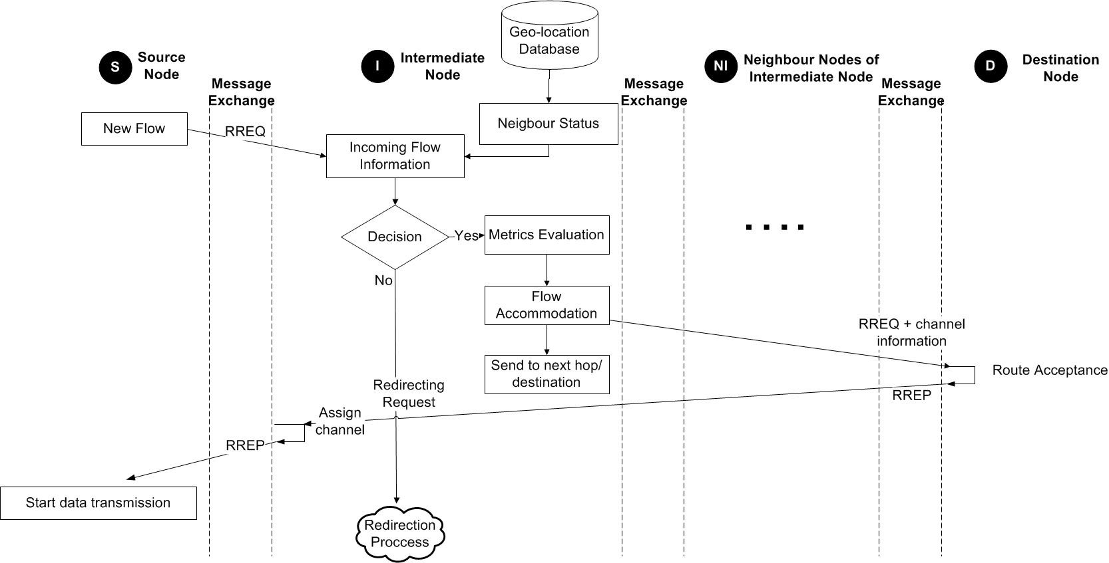

Figure : Message exchanged in CRAHN routing protocol

On the other hand, if the intermediate node is not capable to accommodate the incoming flow, the coordination mechanism of the intermediate node informs the source node, which neighbor node to follow in order to establish a path to the destination. The redirection process is depicted in **Figure 2**, where the intermediate node sends a RREP message to the source node informing that is not able to serve the flow, while it is also sends redirection information. As soon as the source node receives this message, it broadcasts a redirecting RREQ to a new intermediate node. The new intermediate node decides if it will accommodate the flow, then it measure the appropriate cost of the flow and replay to the source that it will serve it. Then the data transmission is starting.

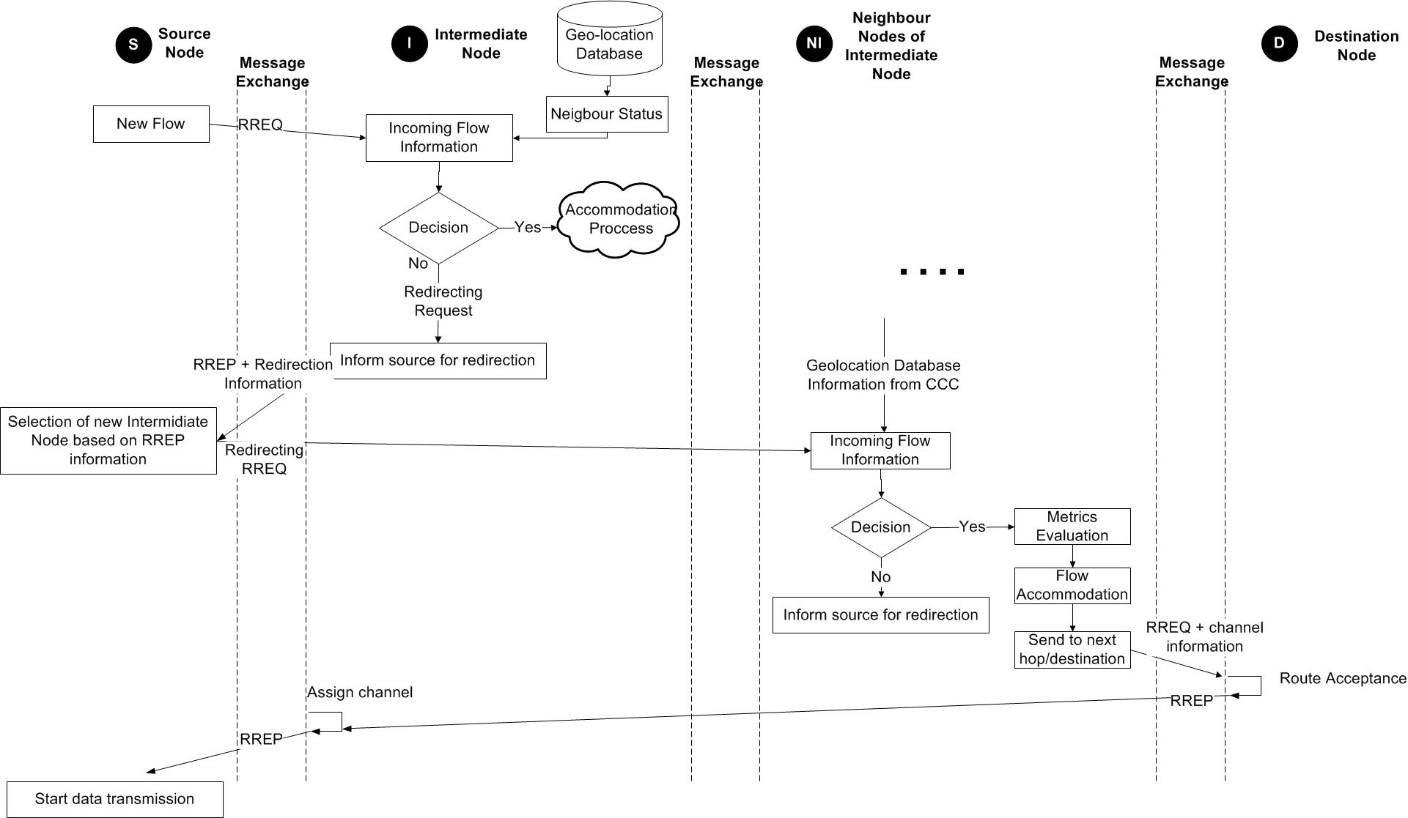

**Figure 2 Message exchanged in CRAHN routing protocol**

CRAHN routing protocol determines a route to a destination only when a node wants to send a packet to that destination. Routes are maintained as long as they are needed by the source. Also, the exploitation of sequence numbers ensure the freshness of routes and guarantee the loop-free routing. The CRAHN routing protocol is extensively described. CRAHN routing protocol, as a reactive one, creates and maintains routes only if these are needed, on a demand basis. These routes are maintained in routing tables, where each entry contains the following information: Destination, Next hop, Number of hops, Destination sequence number, Active neighbours for this route and Expiration time[1]. Also, the control messages that are exchanged between the CR nodes are the route request, route replay, route error, and hello messages. These are presented below in more detailed.

* A **routing request packet** (RREQ) is sent throughout the network, when a route is not available for the destination. The RREQ contains the following fields:



The request ID is incremented each time the source node sends a new RREQ. So the pair (source address, request ID) identifies a RREQ uniquely. On receiving a RREQ message each node checks the source address and the request ID. If the node has already received a RREQ with the same pair of parameters, the new RREQ packet will be discarded. Otherwise the RREQ will be either forwarded (broadcast) or replied (unicast) with a RREP message:

* if the node has no route entry for the destination, or it has one but this is no more an up-to-date route, the RREQ will be rebroadcasted with incremented hop count
* if the node has a route with a sequence number greater than or equal to that of RREQ, a RREP message will be generated and sent back to the source.

The number of RREQ messages that a node can send per second is limited. Every RREQ carries a time to live (TTL) value that specifies the number of times this message should be re-broadcasted. This value is set to a predefined value at the first transmission and increased at retransmissions. Retransmissions occur if no replies are received. Such floodings used a TTL large enough - larger than the diameter of the network - to reach all nodes in the network, and so to guarantee successful route discovery in only one round of flooding. However, this low delay time approach causes high overhead and unnecessary broadcast messages.

* On the other hand, if a node is the destination, or has a valid route to the destination, it unicasts a **route reply message** (RREP) back to the source. This message has the following format



The reason one can unicast RREP back is that every node, forwarding a RREQ message caches a route back to the source node.

* All nodes monitor their own neighbourhood. When a node in an active route gets lost, a **route error message** (RERR) is generated to notify the other nodes on both sides of the link of the loss of this link.
* Each node can get to know its neighbourhood by using local broadcasts, so-called **HELLO messages**. Nodes neighbours are all the nodes that it can directly communicate with. These periodic HELLO messages are used in order to be informed regarding the neighbours status. The HELLO messages will never be forwarded because they are broadcasted with TTL = 1. When a node receives a HELLO message it refreshes the corresponding lifetime of the neighbour information in the routing table.

### Future Work

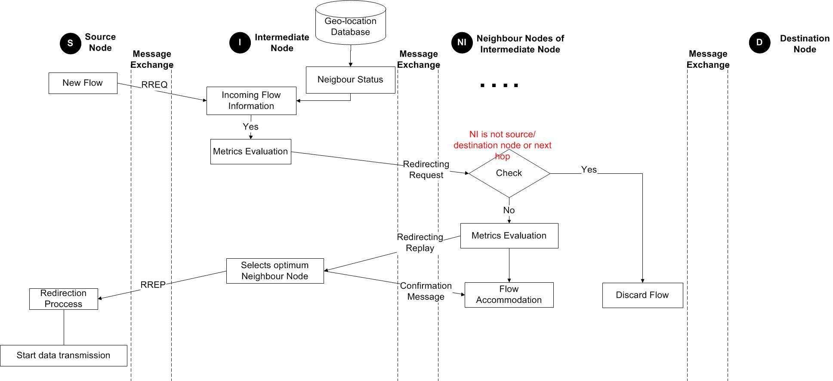

**Figure 3** shows enhancement of the CRAHN routing protocol. More specifically, the coordination mechanism adapted to every intermediate node will be also able not only to sent information regarding the availability of the neighbors (i.e. from the geo-location database through the CCC) but also to determines if a neighbor node performs better in the routing path. For this issue the message exchanged for CRAHN protocol will be modified in order to consider this new feature of the coordination mechanism. When a source node initializes a new flow by sending a RREQ, the intermediate node informed regarding the neighborhood status from the geo-location database through the CCC. Then the intermediate node evaluates the new flow (i.e. throughout specific metrics) and then encapsulates the evaluation result in a message that it will forward to all neighbors. This message is the Redirecting request. Once the neighbors receives a Redirecting request, they check its validity with the corresponding flow, ensuring that they are not the source/destination nodes or next-hop nodes of that flow. Then the neighboring nodes initiate a process in order to evaluate the flow and then they send to the intermediate node the result of the evaluation through a Redirecting replay message. Once the intermediate node receives the Redirecting reply from several of its neighbors, it then selects the optimum one neighbor in order to serve/accommodate the incoming flow. Finally, the intermediate node generate a RREP message in order to inform the source node regarding the new candidate intermediate node, while it is send also a confirmation message to the new intermediate node informing that it is chosen to handle the flow. On the side of source node, once receiving the RREP, changes the next-hop node and start data transmission.

1. Expiration time, also called lifetime, is reset each time the route has been used. The new expiration time is the sum of the current time and a parameter called active route timeout, that is the time after which the route is considered as invalid, and so the nodes not lying on the route determined by RREPs delete their reverse entries. If active route timeout is big enough route repair will maintain routes.